SQL Business Operations Dashboard (BOD) Project

Overview
This project simulates a comprehensive business operations dataset (BOD) and demonstrates advanced SQL techniques for data analysis, performance tracking, and database optimization. It covers multiple business domains including employee performance, product sales, customer feedback, inventory management, and database engineering.
Key Concepts Demonstrated
- Aggregate analysis (SUM, AVG, COUNT)
- Window functions (RANK)
- Common Table Expressions (CTEs)
- Views, Indexes, Stored Procedures, Triggers, and UDFs
- Departmental and category-level breakdowns
- Performance optimization techniques
Dataset Assumption
The BOD table includes fields such as:
- employee_id, employee_name, employee_role, employee_performance_score
- department, salary, training_program_completed
- product_id, product_name, category, revenue, profit_margin, units_sold, customer_feedback_score
- supplier_name, inventory_level
- company_id

Analysis Queries
Employee Performance
-- Highest average profit margin by department
SELECT department, AVG(profit_margin) AS avg_margin
FROM BOD
GROUP BY department
ORDER BY avg_margin DESC;

-- Total revenue
SELECT SUM(REVENUE) FROM BOD;

-- Top 5 IT employees by performance score
SELECT TOP 5 department, employee_name, employee_role
FROM BOD
WHERE department = 'IT'
ORDER BY employee_performance_score DESC;

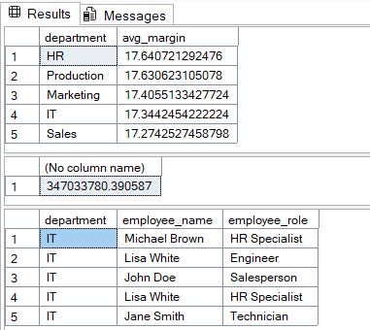

Product Sales & Customer Satisfaction
-- Highest revenue product in HR
SELECT product_name, SUM(revenue) AS total_revenue
FROM BOD
WHERE department = 'HR'
GROUP BY product_name
ORDER BY total_revenue DESC;

-- Accessories category: average feedback and top-rated product

-- Average score
SELECT AVG(customer_feedback_score) AS avg_feedback
FROM BOD
WHERE category = 'Accessories';

-- Product with highest score
SELECT TOP 1 product_name, customer_feedback_score
FROM BOD
WHERE category = 'Accessories'
ORDER BY customer_feedback_score DESC;
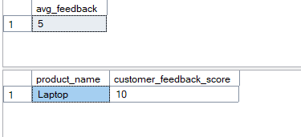

Supply Chain & Inventory
-- Supplier with highest total inventory
SELECT TOP 1 supplier_name, SUM(inventory_level) AS total_inventory
FROM BOD
GROUP BY supplier_name
ORDER BY total_inventory DESC;
-- Lowest inventory product in Gadgets
SELECT product_name, SUM(inventory_level) AS lowest_inventory
FROM BOD
WHERE category = 'gadgets'
GROUP BY product_name
ORDER BY lowest_inventory ASC;
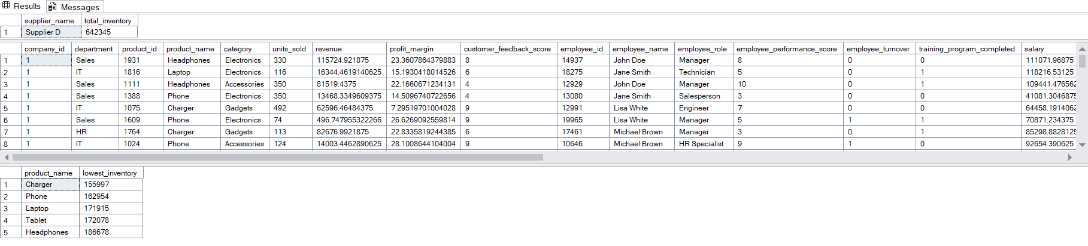

Employee Training & Sales
-- Training completion count and percentage in Sales
SELECT COUNT(*) AS training_completed
FROM BOD
WHERE department = 'Sales' AND training_program_completed = '1';

select count(*) as joined_training ,
department from BOD
where department = 'sales'
group by department

SELECT
(SELECT COUNT(*) FROM BOD WHERE Department = 'Sales' AND training_program_completed = '1') * 100.0 /
(SELECT COUNT(*) FROM BOD WHERE Department = 'Sales') AS CompletionRate;


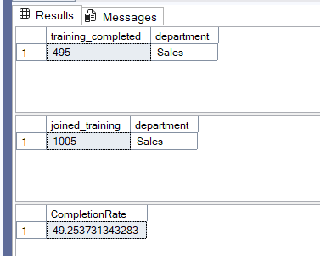

Product Sales Contribution
-- Total units sold and top contributor in Marketing
SELECT SUM(units_sold) AS total_units_sold
FROM BOD
WHERE department = 'Marketing';

SELECT product_name, SUM(units_sold) AS units
FROM BOD
WHERE department = 'Marketing'
GROUP BY product_name
ORDER BY units DESC;
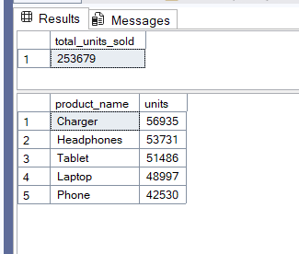

Advanced SQL Techniques
Ranking Employees by Revenue
SELECT employee_id, employee_name, department, revenue,
RANK() OVER (PARTITION BY department ORDER BY revenue DESC) AS rank
FROM BOD;
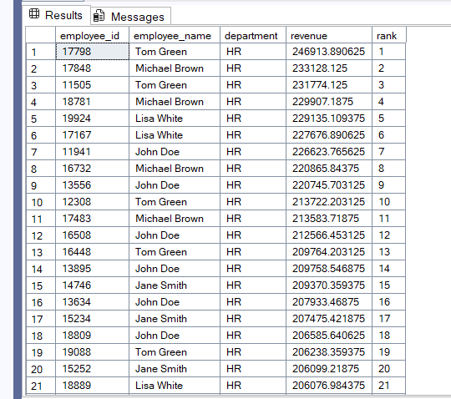

CTE for Department Salary Analysis
WITH DepartmentSalary AS (
SELECT department, AVG(salary) AS avg_salary
FROM BOD
GROUP BY department
)
SELECT * FROM DepartmentSalary
WHERE avg_salary > 70000;
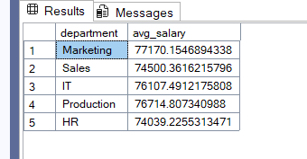

View for Accessories Products
CREATE VIEW Accessories_product_name AS
SELECT product_name, category, revenue, profit_margin
FROM BOD
WHERE category = 'Accessories';

-- View usage
SELECT * FROM Accessories_product_name;
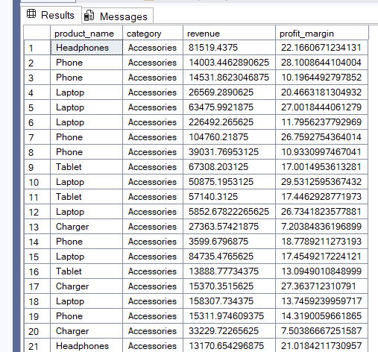

Index Creation
-- Non-clustered index on employee_name
CREATE NONCLUSTERED INDEX idx_employee_name ON BOD (employee_name);

-- Clustered index on company_id
CREATE CLUSTERED INDEX idx_company_id ON BOD (company_id);

Stored Procedure for Department Revenue
CREATE PROCEDURE getdepartmentrevenue @department_name VARCHAR(50)
AS
BEGIN
SELECT SUM(revenue) AS department_revenue, department
FROM BOD
WHERE department = @department_name
GROUP BY department
END;

-- Execution
EXEC getdepartmentrevenue 'HR';
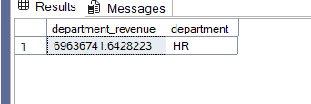

Trigger for Revenue Change Logging
CREATE TRIGGER trg_log_revenue_change
ON BOD
AFTER UPDATE
AS
BEGIN
IF UPDATE(revenue)
BEGIN
INSERT INTO RevenueLog (product_name, old_revenue, new_revenue, change_date)
SELECT d.product_name, d.revenue, i.revenue, GETDATE()
FROM deleted d
JOIN inserted i ON d.product_id = i.product_id;
END
END;

Scalar UDF for Profit Calculation
CREATE FUNCTION dbo.calculates_profit (
@revenue DECIMAL(10,2),
@profitmargin DECIMAL(5,2)
)
RETURNS DECIMAL(10,2)
AS
BEGIN
RETURN @revenue * (@profitmargin / 100)
END;

-- Usage
SELECT product_name, revenue, profit_margin,
dbo.calculates_profit(revenue, profit_margin) AS profit
FROM BOD;
